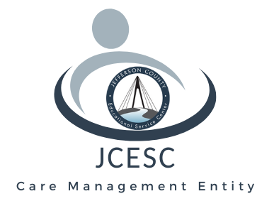
Jefferson County Educational Service Center

2023 Sunset Blvd., Steubenville, Ohio 43952 Phone: 740-792-4011 Fax: 740-283-2709
24-Hour CRISIS HOTLINE # 740-792-4012
“An Equal Opportunity Employer”

Contact: Superintendent Dr. Chuck Kokiko For Immediate Release
(740) 283-3347

Aetna, OhioRISE Assist East Palestine Families

STEUBENVILLE-Aetna Better Health of Ohio and the Jefferson County Educational Service Center’s OhioRISE program are reaching out to assist families they serve in East Palestine following the toxic train derailment in that community.

The organizations provided cleaning supplies and other essentials for five families involved with the program that were temporarily displaced by the disaster on Feb. 3. JCESC’s OhioRISE program, which stands for Resilience through Integrated Systems and Excellence, is a specialized Medicaid managed care system for children and youth with complex behavioral health and multisystem needs and Aetna serves as the managed care partner. JCESC is one of 18 care management entities (CME’s) for OhioRISE and represents an eight-county region known as Catchment J that includes Jefferson, Belmont, Harrison, Carroll, Columbiana, Monroe, Tuscarawas and Stark.

CME Program Director Linda Trushel collaborated with Amy Swanson, Aetna OhioRISE contract administrator and state liaison, and Maryalice Surgenavic, CME supervisor for Catchment J in Columbiana and Stark counties, to aid those families so they could resume their lives with some sense of normalcy.

“Aetna reached out to me on Feb. 15,” Trushel said. “Amy Swanson said she had been glued to the news stories on the train derailment. She was so devastated for that area of the state.”

Swanson had wondered about community needs and whether OhioRISE members were struggling. Efforts were soon underway to order supplies including Clorox Multi-Purpose Cleaning Spray System starter kits, Mrs. Meyer’s Kitchen Essentials sets with hand and dish soap and all-purpose cleaner, trash bags and a care package of snacks to help them as they returned home. The items were delivered with a note from Aetna Better Health -- OhioRISE around Feb. 20.

Trushel said it was one small way to further assist those affected by the derailment.

“This is a true random act of kindness,” she continued. “JCESC has been working with Aetna since March 2022 and this shows how much they truly care about all OhioRISE members in Ohio.”

The OhioRISE initiative currently serves 250 families with offices located in Steubenville and Canton. Care management coordinators help complete a Child and Adolescent Needs and Strengths (CANS) assessment to determine eligibility and offer referrals for counseling, therapy and finding community resources. Assistance is rendered for mental health and substance use while youth with multisystem needs are often involved in community systems such as juvenile justice, child protection, developmental disabilities, education and addiction treatment. Children covered by Medicaid will obtain assistance and those with private insurance can receive a waiver for help. For more information, contact Trushel at (740) 406-0440 or go online at Care Management Entity (jcesc.k12.oh.us). A 24-hour crisis hotline is also available at (740) 792-4012.

-30-

